Author: Anish Mahapatra  
Shallow Neural Networks

Superscripts will be used to denote the later. [1] would indicate layer 1, [2] would indicate layer 2 and so on.  
Superscripts with () brackets are used to indicate training examples.

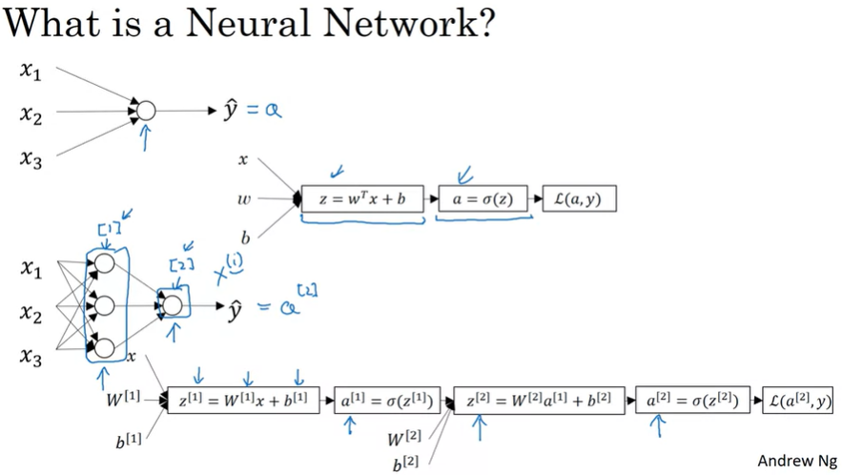

For logistic regression, we had the z followed by a calculation. In this neural network, we jut do it multiple times, as a z followed by a calculation, and a z followed by a calculation and then we finally compute the loss in the end.

**Neural Network Representation**

Input Layer -> [Hidden layer] -> Output Layer  
a -> activations (values that different layers are passing on to the neural network.

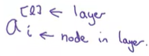

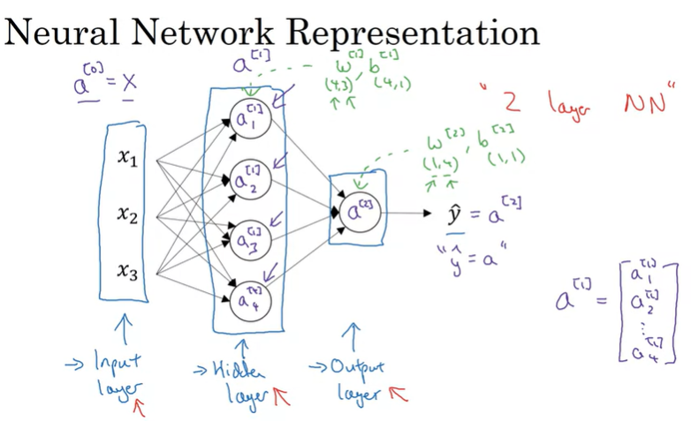

Number of layers in a neural network: INPUT Layer is not counted. So the above would be a 2 – Layer – Neural network.  
Layers 0, 1, 2 -> 2 Layer NN

w[2] (input), b[2] (output)

w[2] dimension is (1,4) because the hidden layer has 4 hidden units and the output layer has just one hidden unit

